**• Definition:**

* **An array is a collection of elements, typically of the same data type, stored in contiguous memory locations.**
* **Syntax: int a[] = new int[100];**
* **Array’s superclass is the Object class.**
* **Array occupies memory on the heap.**
* **Index value starts from 0.**
* **As compared to primitive data types, arrays are faster.**
* **Objects can also be stored in an array (e.g., Employee em[] = new Employee[100];).**
* **Disadvantages:**
  + **Size must be fixed.**
  + **Wastage of memory.**
  + **Only similar data types can be stored.**

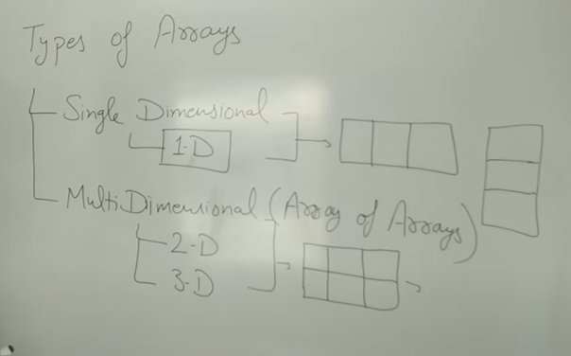**• Types of Arrays:**

* **Single Dimension (1D)**
* **Multidimension Array**

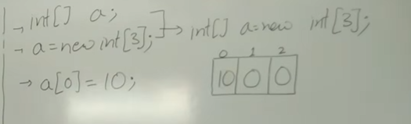Int a[]=new int[0]; //it will compile

Int a[]=new int[-3]; //error



